**DAILY ONLINE ACTIVITIES SUMMARY**

|  |  |  |  |  |  |  |  |  |
| --- | --- | --- | --- | --- | --- | --- | --- | --- |
| **Date:** | **24/06/2020** | | | | | **Name:** | **NAIPUNYA VINOD NAIK** | |
| **Sem & Sec** | **IV SEM & A SECTION** | | | | | **USN:** | **4AL18CS050** | |
| **Online Test Summary** | | | | | | | | |
| **Subject** | | **NO INTERNALS CONDUCTED** | | | | | | |
| **Max. Marks** | | **N/A** | | **Score** | | | **N/A** | |
| **Certification Course Summary** | | | | | | | | |
| **Course** | **1)DEEP LEARNING FOR BEGINNERS: NEURAL NETWORKS IN R STUDIO**  **2)WEBINAR ON C PROGRAMMING** | | | | | | | |
| **Certificate Provider** | | | **1)UDEMY**  **2) AIET** | | **Duration** | | | **1)8 HRS**  **2) 1.5 HR** |
| **Coding Challenges** | | | | | | | | |
| **Problem Statement: NO PROBLEM STATEMENT** | | | | | | | | |
| **Status:------------------** | | | | | | | | |
| **Uploaded the report in Github** | | | | | **YES** | | | |
| **If yes Repository name** | | | | | <https://github.com/naipunya-naik/daily-progress-report> | | | |
| **Uploaded the report in slack** | | | | | **YES** | | | |

Online Test Details: (Attach the snapshot and briefly write the report for the same)

NO INTERNALS CONDUCTED

Certification Course Details: (Attach the snapshot and briefly write the report for the same).

CERTIFICATION COURSE NAME:- DEEP LEARNING FOR BEGINNERS :NEURAL NETWORKS IN R STUDIO

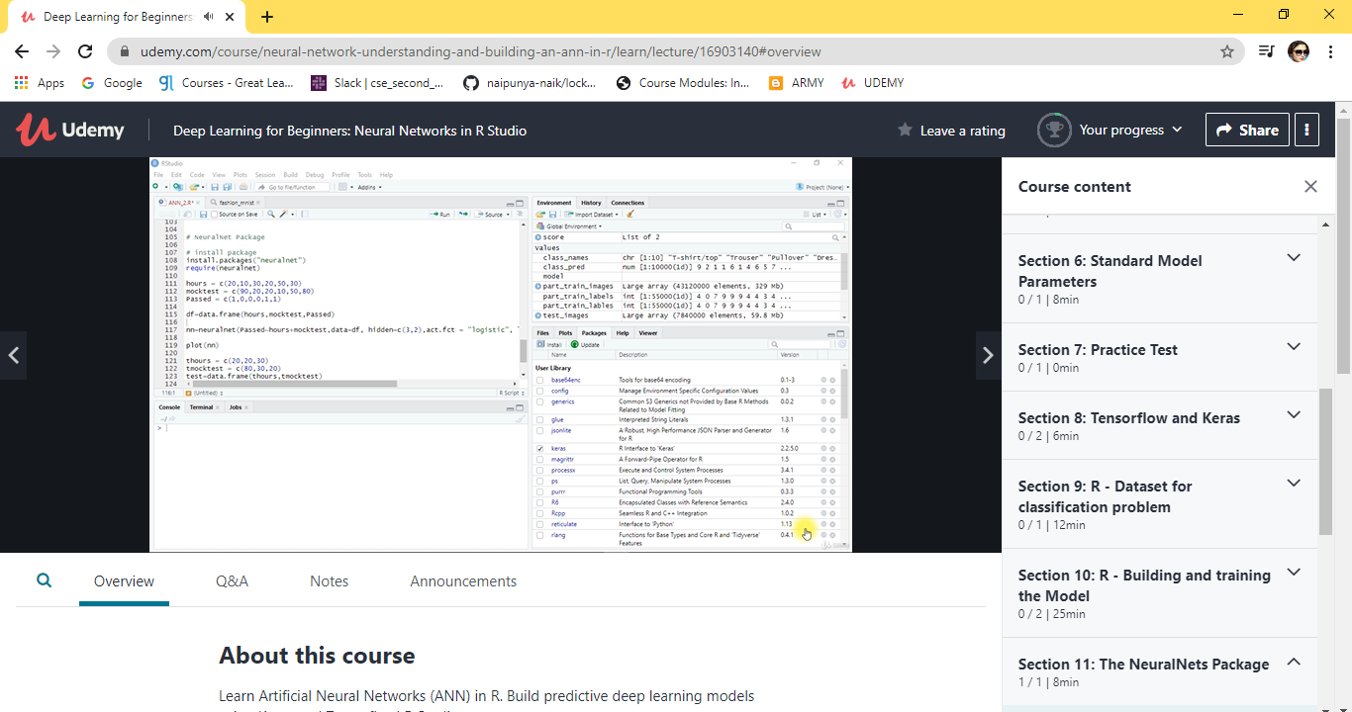

TOPICS LEARNT ON 24 JUNE 2020:-

* **Part 1 - Setting up R studio and R Crash course**
* **Part 2 - Theoretical Concepts**
* **Part 3 - Creating Regression and Classification ANN model in R**
* **Part 4 - Data Preprocessing**
* **Part 5 - Classic ML technique - Linear Regression**
* **Part 6 - Standard Model Parameters**

2) TODAY, I ATTENDED A WEBINAR ON C PROGRAMMING, THE SESSION WAS CONDUCTED BY MS. MEGHA.D.HEGDE ,ASSISTANT PROFESSOR , AIET MIJAR, FROM 2.30PM TO 4.00 PM.

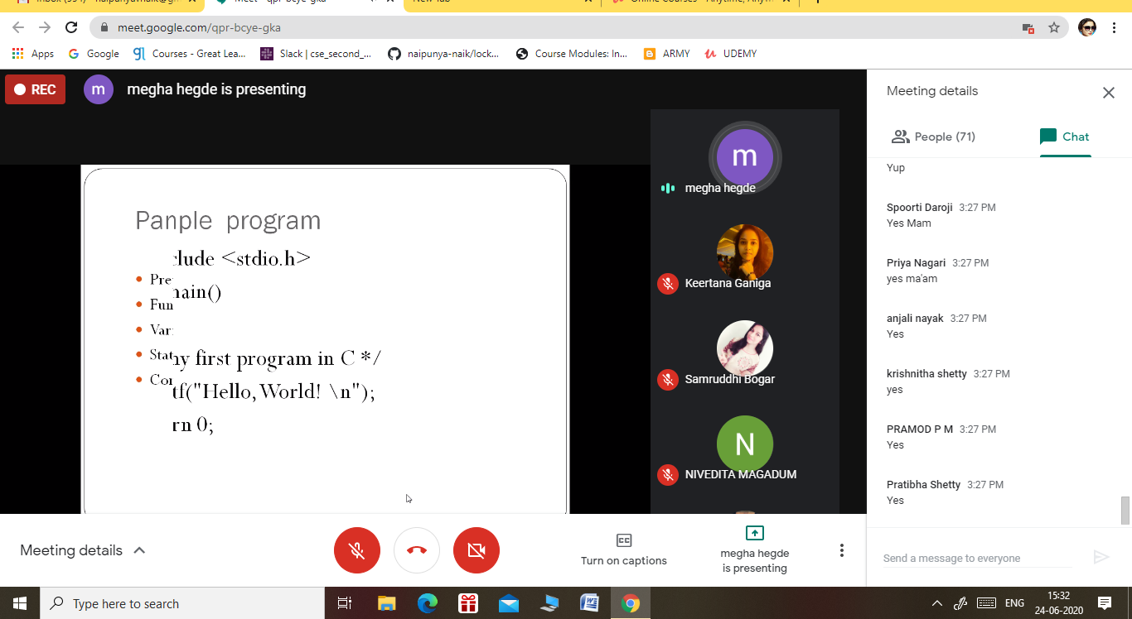

TOPIC LEARNT FROM THIS SESSION:-

* BRIEF INTRODUCTION ABOUT C PROGRAMMING LANGUAGE
* HISTORY OF C
* PARTS OF C PROGRAM
* SAMPLE PROGRAM
* PREPROCESSOR COMMANDS
* FUNCTIONS
* VARIABLES
* STATEMENTS
* EXPRESSIONS
* COMMENTS

THE QUIZ WAS CONDUCTED AFTER THE SESSION.

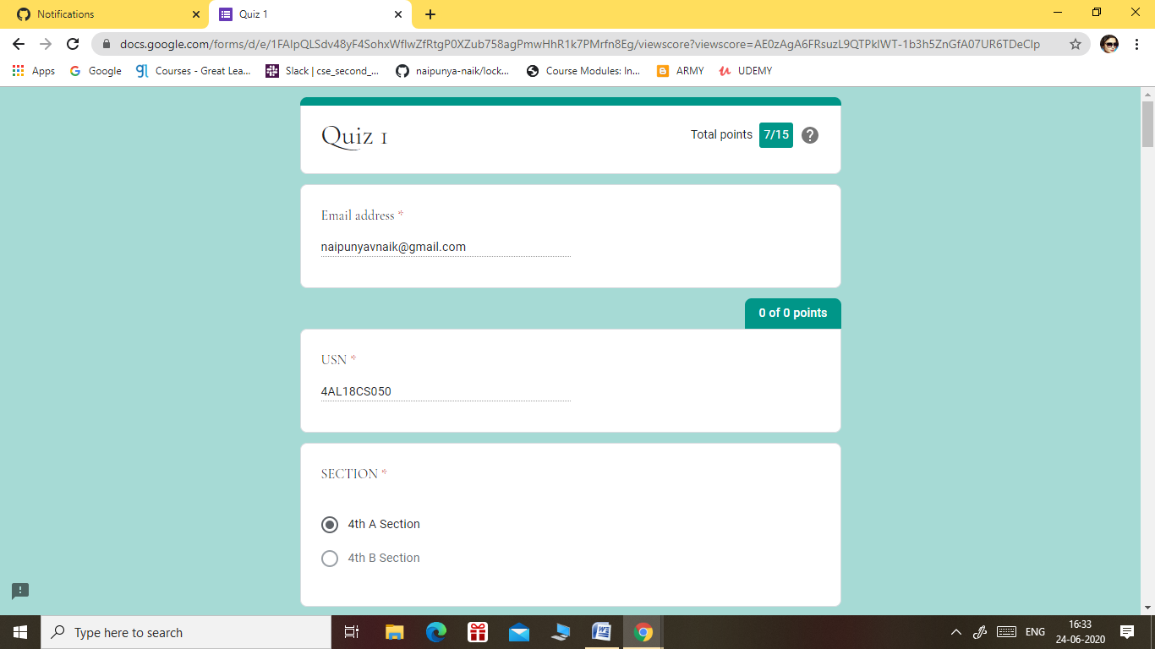

THIS IS THE SNAPSHOT OF THE QUIZ CONDUCTED TODAY.

TOTAL NO.OF QUESTIONS:- 15

DURATION:- 10 MIN

Coding Challenges Details: (Attach the snapshot and briefly write the report for the same)

NO PROBLEM STATEMENTS WERE GIVEN TODAY.